# AWS LAMBDA

What is Lambda?

* It can be used as an event-driven compute service where AWS Lambda runs your code in response to events. These events could be changes to data in an Amazon S3 bucket or an Amazon DynamoDB table.
* It can be used as a compute service to run your code in response to HTTP requests using Amazon API calls made using AWS SDKs.

How to create a Lambda function?

1.Sign in to the AWS Management Console.

2.Click on the Lambda service.

3.Select the Mumbai(ap-south-1) region as it contains almost all AWS resources.

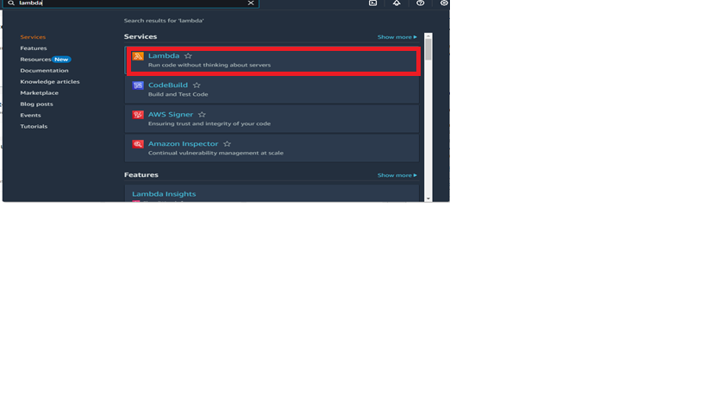

STEP 1:Click on the Create function

1.Go to the create function

2.Select author from scratch

3.Give the function name

4.In runtime, select python 3.9

5.Click on create function,the function is created.

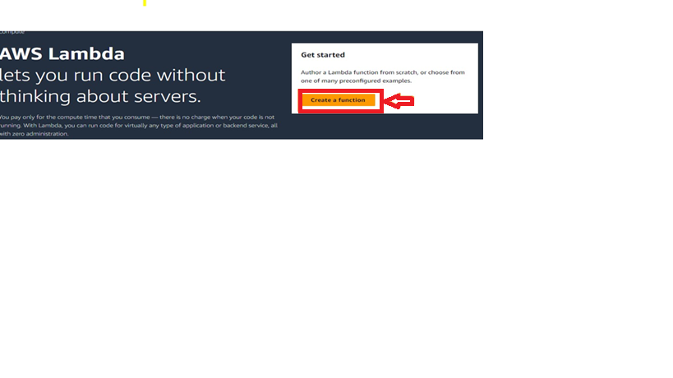

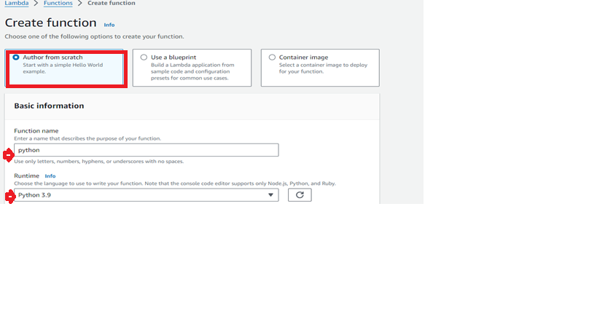

The below image is as shown successfully created the function python.

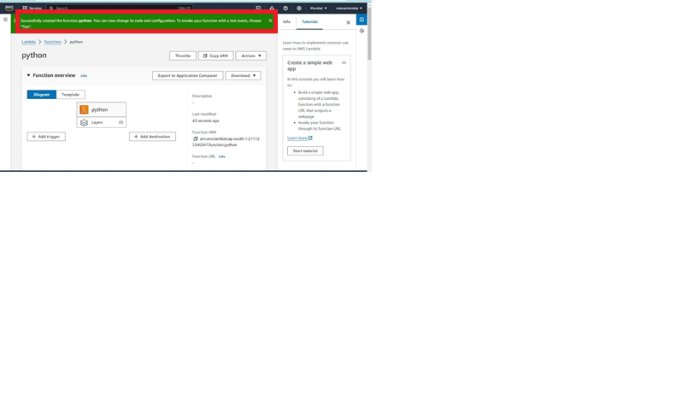STEP2:Select the function and click on the test

1.Test event action

2.select new event

3.Give event name

4.Event sharing settings ,

5.select shearable or private

6.Click on test

The test is successfully executed.

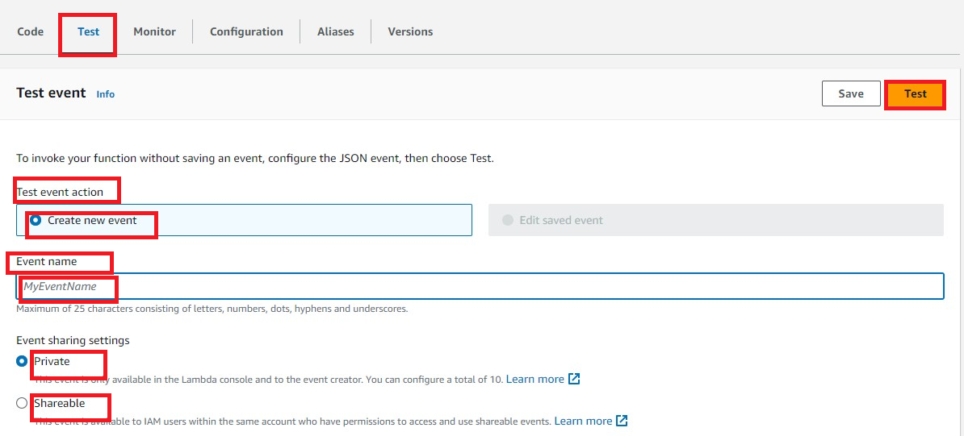

WHAT IS API?

* API stands for Application Programming Interface.
* It is the software responsible for the connection for the communication and information exchange between two apps.
* API connects two devices or programs in order to facilitate the exchange of information between them.

STEP 3:Here we go for API,search API in AWS CONSOLE .

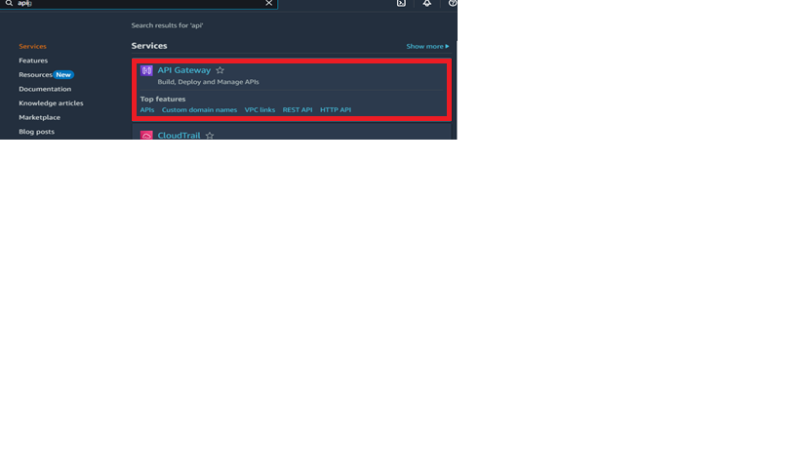1.Select API Gateway

2.Go for below we have option REST API select

3.Click on build

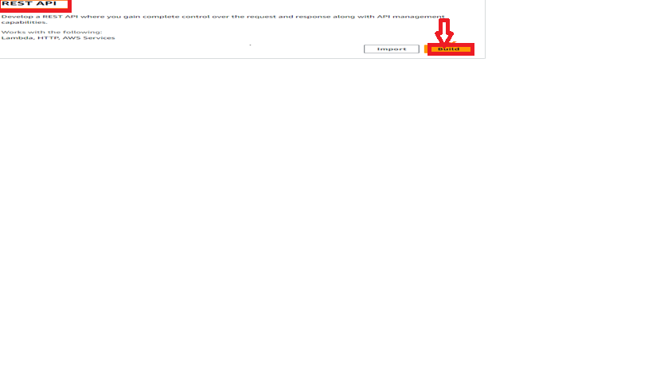The API Details we have to give

1.Select NEW API

2.Give the API NAME as (my api)

3.Description (optional)

4.Click on create API

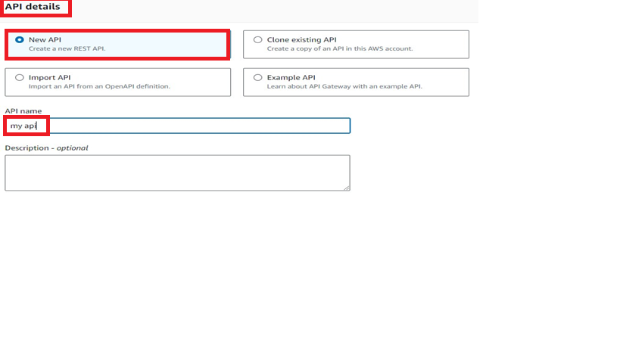The below Image shows successfully created REST API:

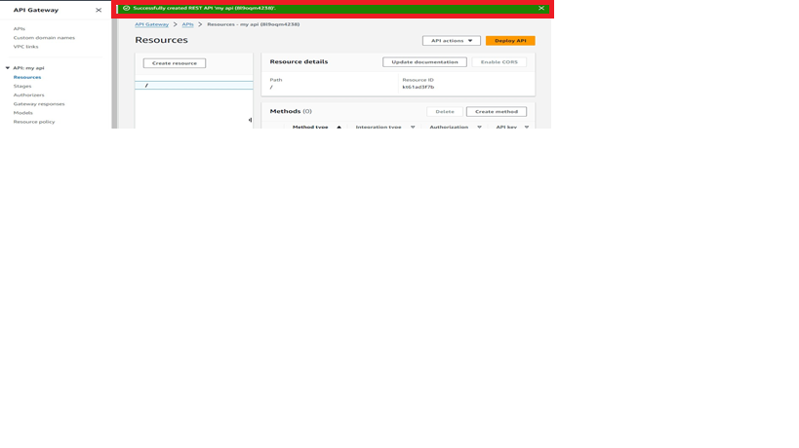

STEP 4: Deploy API

1.Click on Deploy API

2.select stage as new stage

3.Give stage name

4.Click on Deploy

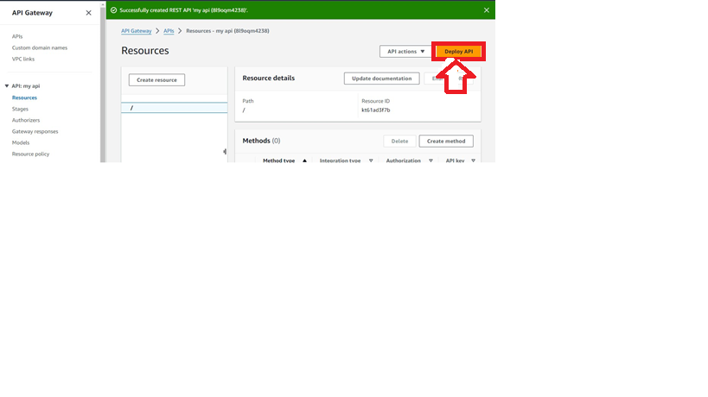

STEP 5: Create method

1.Give method type as GET

2.Select lambda function

3.Select the path of our ARN path

4.click on create method

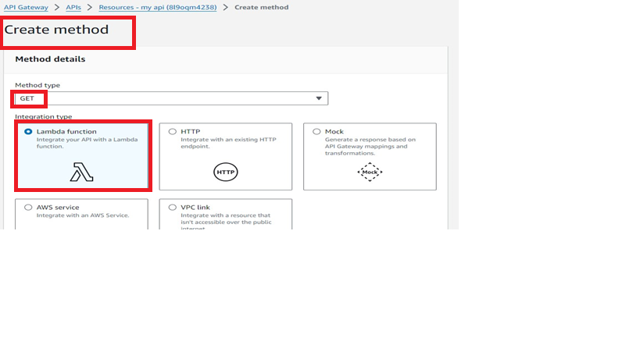

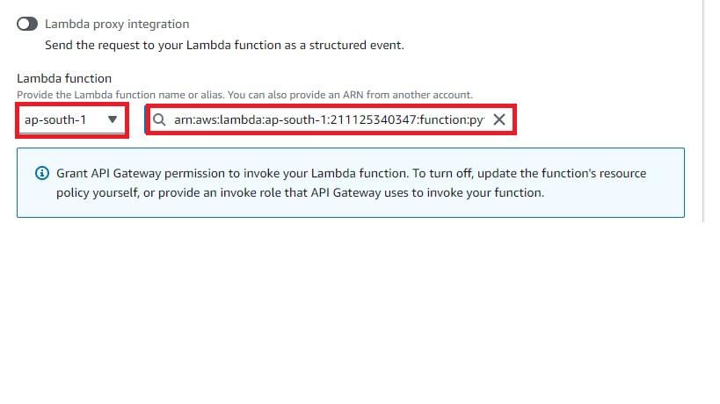The below image shows as successfully created Method ‘GET’.

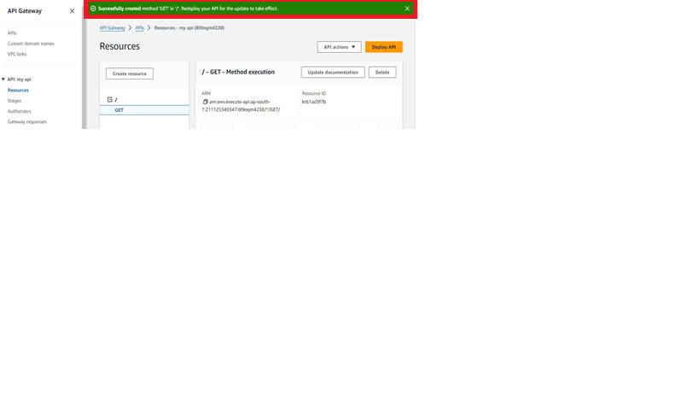

STEP 6: Deploy API

1.Deploy API

2.Stage name

3.Deployment description

4. Click on Deploy

5.Invoke URL is generated

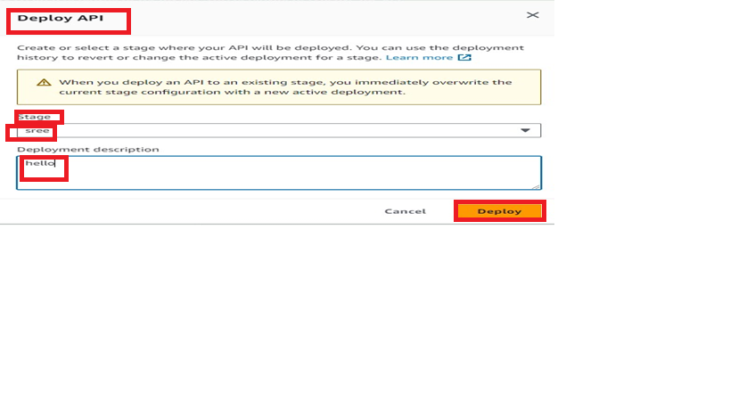

The below image shows successfully created deployment for my API.

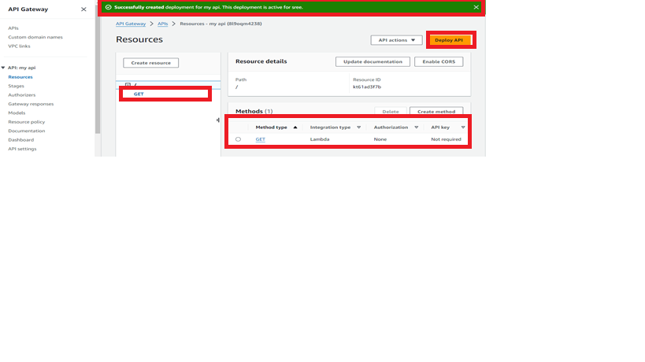

The invoke URL IS Generated:

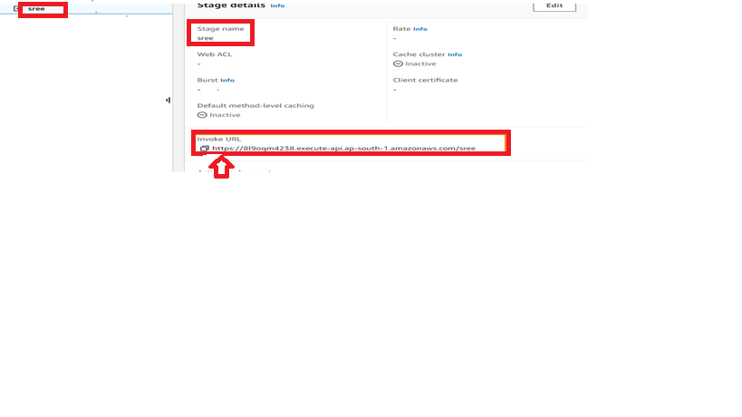 STEP 7: we can copy and paste the URL in chrome:

The output is as shown below:

